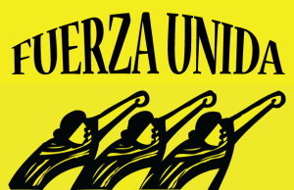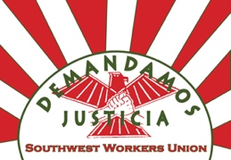

For Immediate Release: Fuerza Unida – 210. 927.2294. Southwest Workers Union – 210.299.2666

San Antonio Demands Climate Accountability

Fuerza Unida and Southwest Workers Union, calls on local leaders to build a robust San Antonio Climate Action Plan in the midst of the reckless actions of President Trump. While the accord was far from reaching our goals, it was an indication that nations were serious about talking about climate change. “Our number one concern with the agreement was “The Agreement relies on voluntary versus mandatory emission cuts that do not meet targets scientists say are necessary to avoid climate catastrophe.”” – Grassroots Global Justice supported over 200 frontline community leaders including Fuerza Unida and SWU in Paris, France for the Paris Agreement.

As climate change rises, the frequency and intensity of normal weather patterns will increase, such as increased hailstorms, rapid flooding, drought, and the recent storm that saw 5 tornados touch down in the northwest side. Furthermore, the pollution of the water ways and air by oil and gas companies continue to plague local residents causing San Antonio to reach non-attainment for air quality. The bans on swimming in natural water within city limits raises safety concerns about the public green spaces. These public health issues are a direct result of extreme extraction of oil and gas, examples include through the building of pipelines, increased diesel trucks, chemicals leaking into the water and flaring. These careless practices impact not only local health but contribute to overall world carbon and chemical emissions.

In order to build a healthier city for both the people and the planet the city must build a climate action plan that includes local food systems, renewable energy, and robust regulation that stops oil and gas companies from polluting the environment and the people. Those who will face the greatest burden rebuilding or protection from such extreme weather will be low wealth, and people of color neighborhoods like the East, South and West Sides of San Antonio.

San Antonio as the largest growing city in South Texas must also ensure that it’s “dirty secrets” will not continue to pollute new or existing residents. CPS has already begun this path by committing to close Deely Coal Power Plan. Equally SAWS has committed to conservation by designing programs on rain catchment. To address the growing needs and urgency of climate matters, city leaders must be transparent, equitable language with develop programing that all residents can access and implement.

In addition of passing a Climate Action Plan, we demand that the Mayor of San Antonio rise up to challenge the undiplomatic practices of the new administration by signing on to the letter alongside hundreds of other cities nationwide.

A Strong Climate Action Plan:
- Promotes and increase bilingual conservation outreach and education.
- Reaches 100% renewable energy, such as solar and wind, by 2040
- Develops inclusive regular community Input Sessions before finalizing the plan
- Stops the Vista Ridge Pipeline and future false solutions project and instead promotes stronger water conservation efforts
- Moves Public Utilities to divest from Coal, Nuclear and Gas Energy – the leaders in destruction of indigenous land, water, and air pollution.

